**Assignment 1: Civil Engineering case study**

Problem statement

I am creating a program that allows the user to calculate and design a rectangular reinforced concrete beam that is supported on two masonry walls 200mm thick and length L. The beam has to carry a distributed permanent load gk (kN/m) and a variable load qk (kN/m). There must be a 60% margin for permanent load and 20% margin for the variable load. The reinforced concrete unit has a constant weight of 25 kN/m3 (Cuw).

When designing the beam I am going to compute the depth and width, total characteristic load, shear force, and bending moment of the beam.

Gathering Information / Input and Output

Formulas needed:

A) Beam Size:

Depth of the beam (h) = Length / 14

Width of the beam (b) = 0.4 * h

Note that depth and width parameters are in millimeter.

B) Total Characteristic Load:

Beam self-weight (Ws) = Depth (h) * Width (b) * Cuw

Total characteristic permanent action = Ws + gk

C) Shear Force and Bending Moment:

First, we need to calculate the Design Action:

Wd = (1+ PERMANENT_LOAD_MARGIN)gk + (1 + VARIABLE_LOAD_MARGIN)qk

Then the shear force (V) is calculated as: V = Wd  * L/2

And the bending moment (M) is calculated as: M = Wd * L2 /8

Now for the user **INPUT**:

-All inputs are via keyboard entry

* We need to get the length in meters from the user
* The permanent load gk in kN/m
* The variable load qk in kN/m
* Integer to repeat program or exit

**OUTPUT:**

* Depth and Width in mm
* Total characteristic load in kN/m
* Shear Force in kN
* Bending moment in kNm

Test Cases and Algorithm

**TEST CASE 1**

This software designs a rectangular beam.

Enter the beam specifications:

Length: 6

Permanent load (gk, kN/m): 10

Variable load (qk, kN/m): 8

Here is a summary of the beam design:

The minimum values for the size of the beam are: Depth = 429 mm, Width = 172 mm

The total characteristic load = 11.8386 kN/m

Shear force (V) = 76.8 kN

Bending moment (M) = 115.2 kNm

Enter 1 to repeat or any other number to exit: 2

Program terminating …

**TEST CASE 2: Testing while loop**

*Start with Test Case 1 and enter 1 at the end…*

Enter 1 to repeat or any other number to exit: 1

This software designs a rectangular beam.

Enter the beam specifications:

Length: 10

Permanent load (gk, kN/m): 20

Variable load (qk, kN/m): 14

Here is a summary of the beam design:

The minimum values for the size of the beam are: Depth = 715 mm, Width = 286 mm

The total characteristic load = 25.102 kN/m

Shear force (V) = 244 kN

Bending moment (M) = 610 kNm

Enter 1 to repeat or any other number to exit: 2

Program terminating …

**TEST CASE 3: Negative numbers**

This software designs a rectangular beam. Enter the beam specifications:

Enter the length of the beam(m): 5

Enter the permanent load(kN/m): -10

Enter a positive integer for the permanent load

This software designs a rectangular beam. Enter the beam specifications:

Enter the length of the beam(m): 4

Enter the permanent load(kN/m): 3

Enter the variable load(kN/m): -5

Enter a positive integer for the variable load

This software designs a rectangular beam. Enter the beam specifications:

Enter the length of the beam(m): 3

Enter the permanent load(kN/m): 5

Enter the variable load(kN/m): 3

Here is a summary of the beam design:

The minimum values for the size of the beam are:

Depth = 215 mm, Width = 86 mm

The total characteristic load = 5.45918 kN/m

Shear force = 17.4 kN

Bending moment = 13.05 kNm

Enter 1 to repeat or any other number to exit:

Algorithm Design

Declare inclusion for iostream and cmath

Declare using namespace std

Define constants for the reinforced concrete unit weight, permanent load margin, and variable load margin.

c_uw = 25 → Concrete unit weight

plm = 0.6 → permanent load margin

Vlm = 0.2 → variable load margin

Create **main** function

Create **double variables** for storing values used in calculations:

l (length)

h(depth)

b(width)

gk(permanent load)

qk(variable load)

V(Shear force)

M (Bending moment)

tcl(total characteristic load)

ws(beam self-weight)

wd(Design action)

Create a **sentinel** for the **while loop** e.g Assign 1 to n

Create a boolean ‘clear’ and assign it true

Create **while loop**:

*While n is equal to 1:*

Create a do-while loop here:

Print “This software designs a rectangular beam. Enter the beam specifications:” newline

Print "Enter the length of the beam(m): "

Read value in l

*If l is less than or equal to 0*

Then set clear to false

Print “Enter a positive integer for the length: ”, newline

Create a newline for space

And continue the loop

*Else*

Set clear to true

Print "Enter the permanent load(kN/m): " ;

Read value into gk

*If gk is less than or equal to 0*

Then set clear to false

Print “Enter a positive integer for the permanent load: ”, newline

Create a newline for space

And continue the loop

*Else*

Set clear to true

Print "Enter the variable load(kN/m): "

Read the value into qk

*If l is less than or equal to 0*

Then set clear to false

Print “Enter a positive integer for the length: ”, newline

Create a newline for space

And continue the loop

*Else*

Set clear to true

*Create condition for do-while loop and set clear equal to false*

Print a newline

*Calculations to be performed on the input:*

h = l/14 * 1000 → depth of beam in millimeters

b = h *0.4 → width of beam in millimeters

ws = h/1000 * b/1000 * c_uw → beam self-weight

tcl = ws + gk → total characteristic load

wd = (1 + plm)*gk + (1 + vlm)*qk → Design action

V = wd * l * 0.5 → shear force

M = wd * l*l * ⅛ → bending moment

Print "Here is a summary of the beam design: ", newline, newline

Print "The minimum values for the size of the beam are: " , newline

Print "Depth = " , h , " mm, " , "Width = " , b , " mm" , newline

Print "The total characteristic load = " , tcl , " kN/m" , newline

Print "Shear force = " , V , " kN" , newline

Print "Bending moment = " , M , " kNm" , newline

Print "Enter 1 to repeat or any other number to exit: " , newline

Read value into n

While loop check value of n with 1

If n is equal to 1, the program is run again

If n is not equal to 1:

Print "Program terminating..." , newline

Implementation

#include <iostream>

#include <cmath>

**using** **namespace** std;

#define c_uw 25 *// constant weight of reinforced concrete beam*

#define plm 0.6 *// permanent load margin*

#define vlm 0.2 *// variable load margin*

**int** main(){

**double** l, h, b, gk, qk, V, M, tcl, ws, wd;

**int** n = 1;

**bool** clear = **true**;

**while** (n == 1) {

**do** {

cout << "This software designs a rectangular beam. Enter the beam specifications:" << endl;

cout << "Enter the length of the beam(m): " ;

cin >> l ; *// Length of beam*

**if** (l <=0){

clear = **false**;

cout << "Enter a positive integer for the length" << endl;

cout << endl;

**continue**;

}

**else**{

clear = **true**;

}

cout << "Enter the permanent load(kN/m): " ;

cin >> gk; *// Permanent load*

**if** (gk <=0){

clear = **false**;

cout << "Enter a positive integer for the permanent load" << endl;

cout << endl;

**continue**;

}

**else**{

clear = **true**;

}

cout << "Enter the variable load(kN/m): " ;

cin >> qk; *// Variable load*

**if** (qk <=0){

clear = **false**;

cout << "Enter a positive integer for the variable load" << endl;

cout << endl;

**continue**;

}

**else**{

clear = **true**;

}

}

**while** (clear == **false**);

cout << endl;

h = l/14 * 1000; *// depth of beam(h) in mm*

b = h * 0.4 ; *// width of beam(b) in mm*

ws = h/1000 * b/1000 * c_uw ; *// beam self-weight*

tcl = ws + gk; *// total characteristic permanent action*

wd = (1 + plm)*gk + (1 + vlm)*qk ; *//Design action*

V = wd*l*0.5 ; *// shear force*

M = wd * pow(l,2) * 1/8 ; *//bending moment*

cout << "Here is a summary of the beam design: " << endl << endl;

cout << "The minimum values for the size of the beam are: " << endl;

cout << "Depth = " << ceil(h) << " mm, " << "Width = " << ceil(b) << " mm" << endl;

cout << "The total characteristic load = " << tcl << " kN/m" << endl;

cout << "Shear force = " << V << " kN" << endl;

cout << "Bending moment = " << M << " kNm" << endl;

cout << "Enter 1 to repeat or any other number to exit: " << endl;

cin >> n;

cout << endl;

}

cout << "Program terminating..." << endl;

}

Testing and Verification

**Test Case 1**

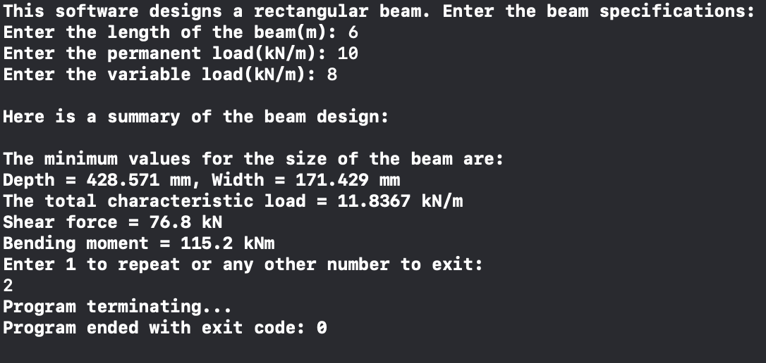

**Test Case 2**

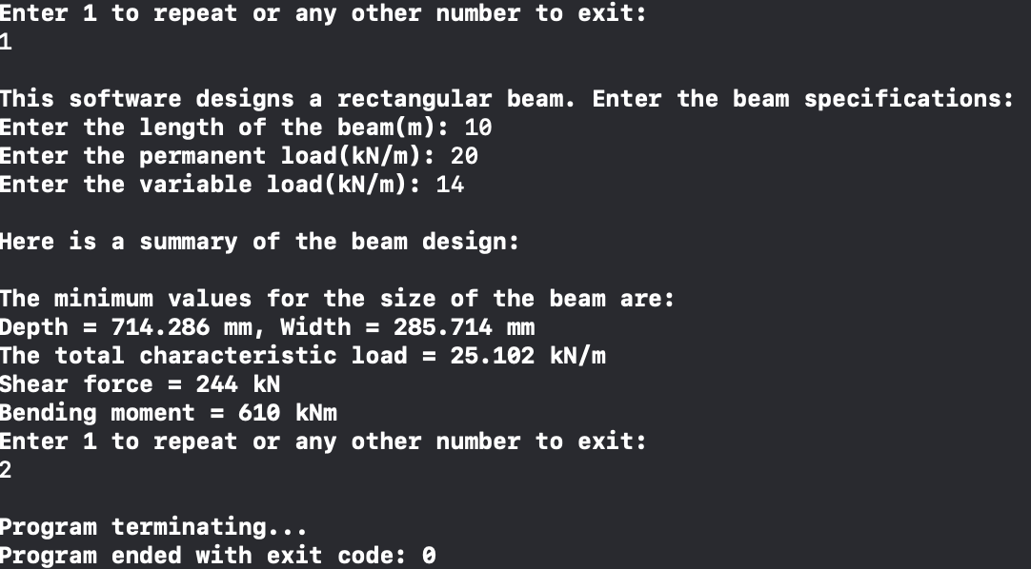

**Test Case 3**

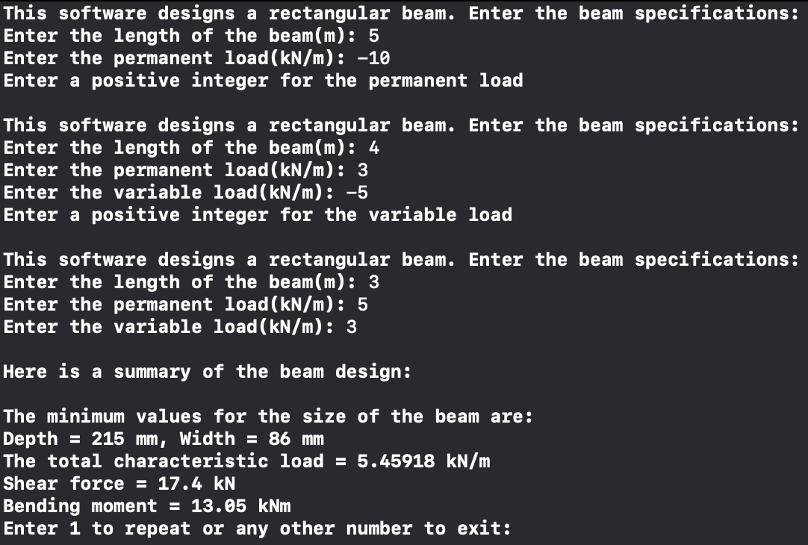

User Guide

To use this software, simply run it in a console and enter the values as required. If you enter negative or zero as any of the inputs, you will be asked to re-enter your values. Please enter only integers into the program. The specifications will be returned to you and if you wish to repeat the program, enter 1 or any other button if you wish to exit the program.